**Institute of Computer Technology**

**B. Tech. Computer Science and Engineering**

**Semester: III**

**Sub: Database Management System**

**Course Code: 2CSE301**

**Practical Number:1**

**Objective:**

*To create database and insert records in the tables.*

* Scenario: Mohan who is a Computer Engineer seeking to start Computer Parts & Accessories Shop. They are planning to build Website and Application for which they met with IT Professionals and gave their requirements to develop the same. Now based on information gathered, IT Company is initiating to create Database.Method using a third variable:

**Exercise:**

1. **Create database in mysql with your branch name and enrollment number.**

**Code :**

CREATE DATABASE DBMS_ICT;

USE DBMS_ICT;

**Output :**



1. **Create table client_master.**

**Code :**

CREATE TABLE client_master (

Client_no VARCHAR(6),

Name VARCHAR(20),

City VARCHAR(15),

Pincode NUMERIC(8),

State VARCHAR(15),

Bal_due NUMERIC(10,2)

);

**Output :**



1. **Create table product_master.**

**Code :**

CREATE TABLE product_master (

Product_no VARCHAR(6),

Description VARCHAR(15),

P_percent NUMERIC(4,2),

U_measure VARCHAR(10),

Qty_on_hand NUMERIC(8),

Reorder_lvl NUMERIC(8),

Sell_price NUMERIC(8,2),

Cost_price NUMERIC(8,2)

);

**Output :**



1. **Create table salesman_master.**

**Code :**

CREATE TABLE salesman_master (

S_no VARCHAR(6),

S_name VARCHAR(20),

City VARCHAR(20),

Pincode NUMERIC(8),

State VARCHAR(20),

Sal_amt NUMERIC(8,2),

Tgt_to_get NUMERIC(6,2),

Ytd_sales NUMERIC(6,2),

Remarks VARCHAR(12)

);

**Output :**



1. **Describe structure for client_master table.**

**Code :**

DESCRIBE client_master;

**Output :**

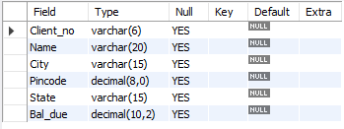

1. **Describe structure for product_master table.**

**Code :**

DESCRIBE product_master;

**Output :**

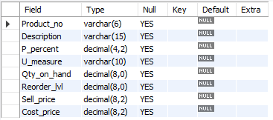

1. **Describe structure for salesman_master table.**

**Code :**

DESCRIBE salesman_master;

**Output :**

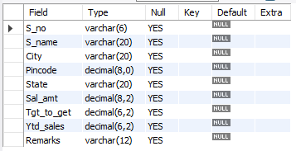

1. **Insert records in client_master table.**

**Code :**

INSERT INTO client_master (Client_no, Name, City, Pincode, State, Bal_due)

VALUES

('C001', 'Ivan', 'Bombay', 400054, 'Maharashtra', 15000),

('C002', 'Vandana', 'Madras', 780001, 'Tamil Nadu', 0),

('C003', 'Pramada', 'Bombay', 400057, 'Maharashtra', 5000),

('C004', 'Basu', 'Bombay', 400056, 'Maharashtra', 0),

('C005', 'Ravi', 'Delhi', 100001, 'Gujarat', 2000),

('C006', 'Rukmani', 'Bombay', 400050, 'Maharashtra', 0);

**Output :**



1. **Insert records in product_master table.**

**Code :**

INSERT INTO product_master (Product_no, Description, P_percent, U_measure, Qty_on_hand, Reorder_lvl, Sell_price, Cost_price)

VALUES

('P001', 'Floppies', 5, 'Piece', 100, 20, 525, 500),

('P002', 'Monitor', 6, 'Piece', 10, 3, 12000, 11280),

('P003', 'Mouse', 5, 'Piece', 20, 5, 1050, 1000),

('P004', 'Floppies', 5, 'Piece', 100, 20, 525, 500),

('P005', 'Keyboards', 2, 'Piece', 10, 3, 3150, 3050),

('P006', 'Cd Drive', 2.5, 'Piece', 10, 3, 5250, 5100),

('P007', '1.44 Drive', 4, 'Piece', 10, 3, 8400, 8000);

**Output :**



1. **Insert records in salesman_master table.**

**Code :**

INSERT INTO salesman_master (S_no, S_name, City, Pincode, State, Sal_amt, Tgt_to_get, Ytd_sales, Remarks)

VALUES

('S001', 'Kiran', 'Bombay', 400002, 'Maharashtra', 3000, 100, 50, 'Excellent'),

('S002', 'Manish', 'Bombay', 400001, 'Maharashtra', 3000, 200, 100, 'Good'),

('S003', 'Ravi', 'Bombay', 400032, 'Maharashtra', 3000, 200, 100, 'Average'),

('S004', 'Ashish', 'Bombay', 400044, 'Maharashtra', 3500, 200, 150, 'Good');

**Output :**



1. **Retrieve all records for client_master table.**

**Code :**

SELECT * FROM client_master;

**Output :**

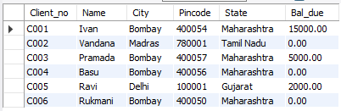

1. **Retrieve product_no, sell_price and cost_price for product_master table.**

**Code :**

SELECT Product_no, Sell_price, Cost_price FROM product_master;

**Output :**

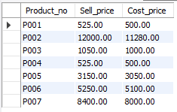

1. **Retrieve s_no,s_name, remarks and sal_amt for salesman_master table.**

**Code :**

SELECT S_no, S_name, Remarks, Sal_amt FROM salesman_master;

**Output :**

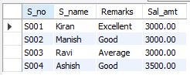

1. **Display all tables for your database.**

**Code :**

SHOW TABLES;

**Output :**

